Collin Real

DA 6823

Kilger

Module 3: Part #2 (15 points)

**Dependent Samples t test**

**General Instructions:** In your own words, answer each of the following questions - don’t copy (e.g. cut and paste) some definition out of a book word for word. This is not a group project – you are expected to complete this module on your own. You may refer to text books, online or other sources but not your fellow classmates. If you don’t understand the question, feel free to ask the instructor in class, in office hours or in an email.

Here is the SAS printout for an dependent samples ttest that compares advertising receptivity (scale =person has low ad receptivity, 5=person has high ad receptivity) before and after the person drinks a shot of tequila.

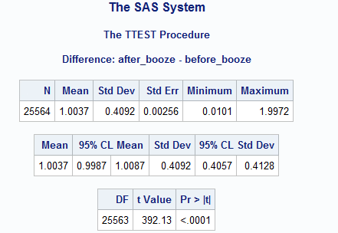

1. State the null and alternative hypotheses for the dependent sample t test. (4 points)

Null: The mean difference between the two groups is not different from 0.

Alternative: The mean difference between the two groups is different from 0.

1. Name one assumption of the dependent sample t test ( 2 points)

The dependent variable must be continuous.

1. What is the difference in the before and after alcohol means? (2 points)

1.0037

1. What can you conclude about the change in advertising receptivity due to the application of alcohol to a respondent? (4 points)

Since the p-value (< 0.0001) is less than the significance level (assuming 0.05), we reject the null hypothesis and conclude that there is a significant effect in the mean difference of a person’s response to ad receptivity before and after a shot of tequila.

1. Why is this called a “paired” or dependent sample t test? (3 points)

It is called a “paired” or dependent sample t test because the sample means from two related groups are compared. The same people are being tested before and after a shot of tequila to determine if there was measurement change caused by alcohol consumption.